**Daily Scrum or Standup Meeting**

Team name: ________Group 2_________________

Scrum Master: ______Emily_________________

Date:________10/19_______________________

| **Team Member** | **What did you do since the last scrum?** | **What do you plan to do before the next scrum?** | **What obstacles do you have?** |
| --- | --- | --- | --- |
| Emily Thomas | Backlog grooming, sprint planning | Start update price markup for manager | Not a lot of time, have to wait on other tasks to be completed first |
| Karl Poulson | Code refactoring | Work on restructuring Manager Dashboard | Flexbox issues |
| Andre Nguyen | Reviewing and cleaning up the models. Started to design the menu item model | Work on implementing the menu item model | Career, busy with other assignments |
| Maris Hurst | Sprint planning, reading up on extending django user class | Start to refactor users to have the attributes each of them needs | Work and other classes- time |
|  |  |  |  |

# Burndown

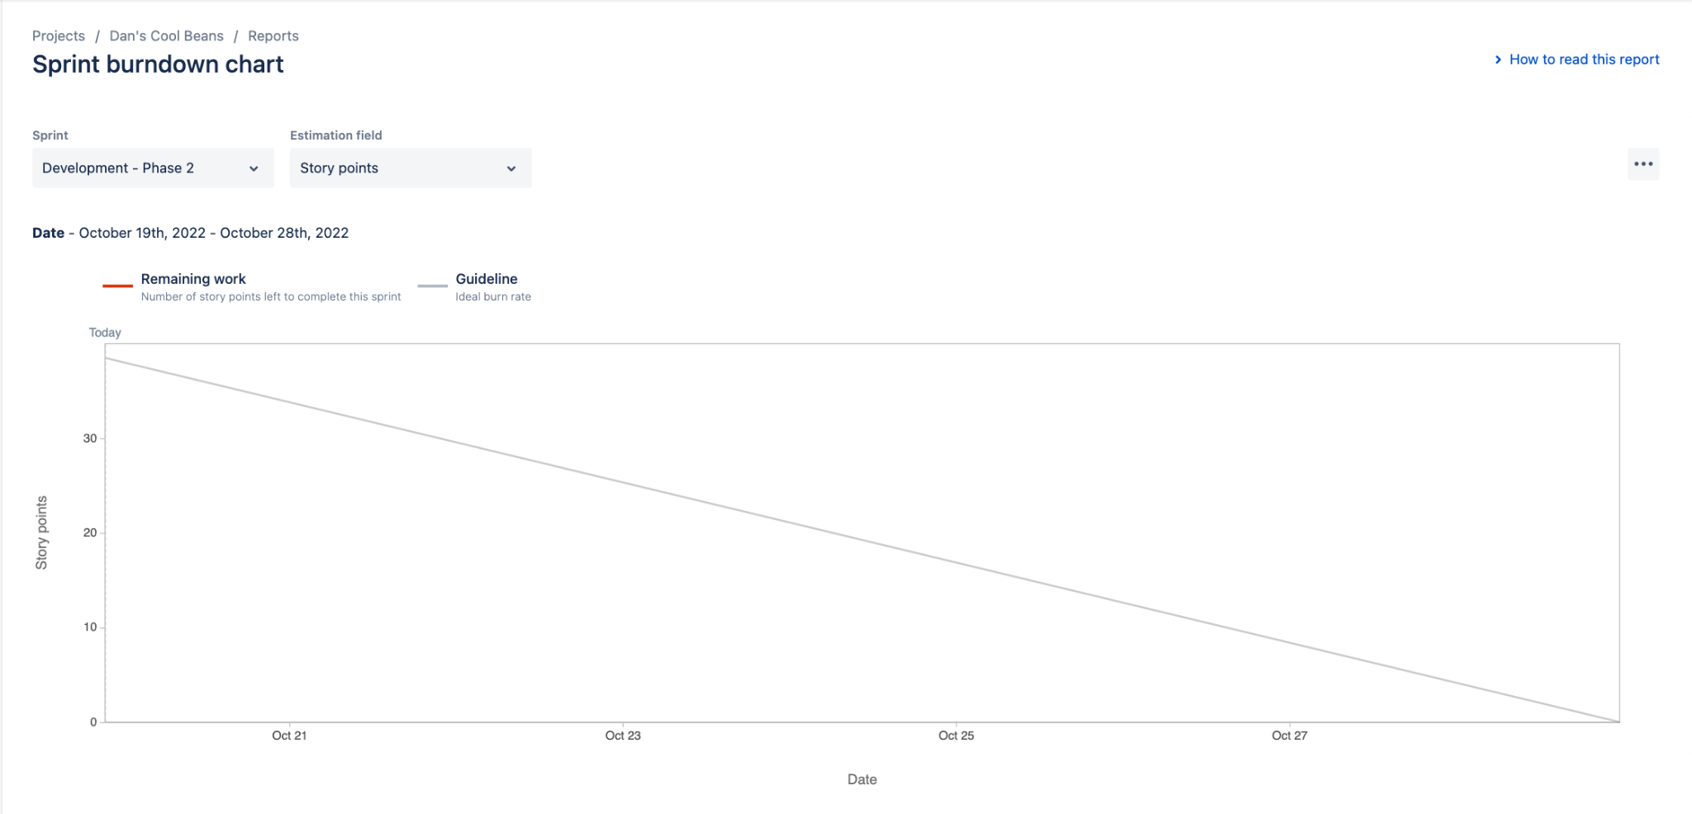

# Screenshot of you project board

